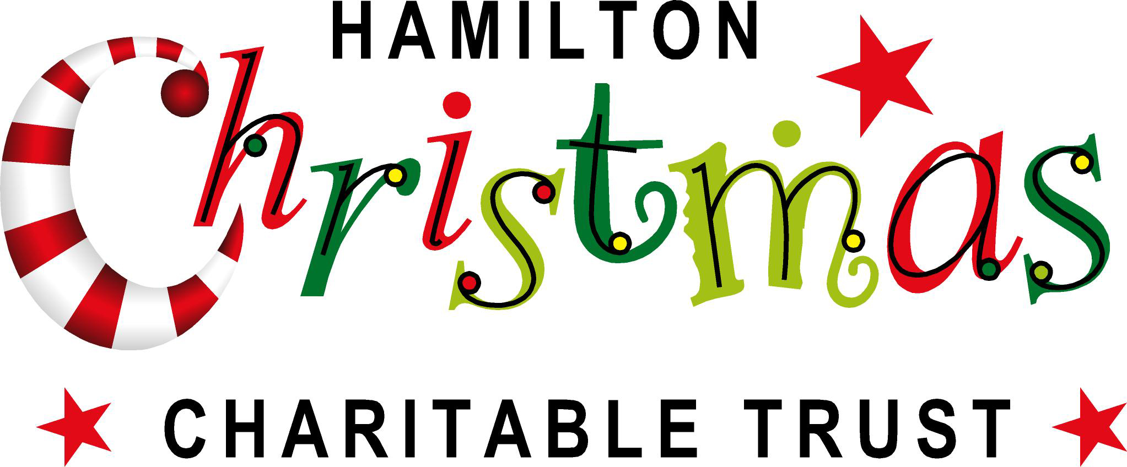

**CHARACTER AND COSTUME APPLICATION FORM**

Thanks for your interest in wanting to wear a costume or character costume for the Hamilton Christmas Charitable Trust

Please complete one form per person and return via mail or email (details below) by **Friday 9 November 2018**

**PLEASE PRINT DETAILS CLEARLY** Tick applicable boxes (you can tick more than one)

**FCU Christmas Parade**

Sunday 9th December 2018

**Tick :**  Male  Female

**Age** 7 – 10 11 – 15 15 – 18 18 – 21 22 – 25 25 – 30 30 +

Name: ………………………………………………………………………………………………………………………….

Address: ………………………………………………………………………………………………………………….........

Home Phone: ……………………… Work Phone: ………………………… Mobile: ………………………………..

Email: ………………………………………………………….. Signed …………………………………………………..

Parents Name & Signature (if under 18): ……………………………………… Date ………………………………….

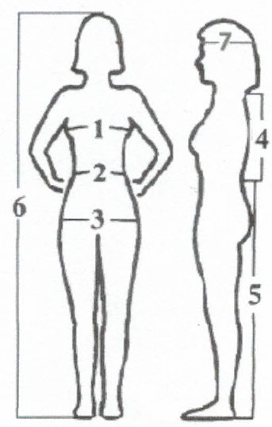Were you in the Parade last year? (Circle) YES NO If yes, what as ………………………………………………………………

Please include the following measurements in centimetres

1. Bust/chest ……………………….
2. Waist …………………………….
3. Hips ………………………………
4. Neck to Waist ………………………….
5. Waist to Floor …………………………
6. Total Height …………………………..
7. Head Circumference …………………
8. Talents? (Circle) – Comedy Dance Outgoing Drama Quietly Confident Other ………………….

I declare that: ………………………………………………

* All the information provided in this Application Form is accurate.
* I am willing to undergo a police check if required.
* I agree to abide by the Parade rules and regulations and that I participate in the Parade at my own risk.
* I give permission to the Hamilton Christmas Charitable Trust to use my name and photograph for advertising, trade, and any other lawful purposes.

Thank you again, we will be allocating costumes and character costumes in November and sending out instructions closer to the date of the event/events you have indicated. This year you will be asked to attend a briefing. The briefing may be in the evening on a week night.

Please return completed form and refer any queries to: Karen Watkins, Parade Manager, Hamilton Christmas Charitable Trust, PO Box 1561, Waikato Mail Centre, Hamilton 3240 Phone: 021 775 647 Email: [karen@hamiltonchristmas.co.nz](mailto:karen@hamiltonchristmas.co.nz)